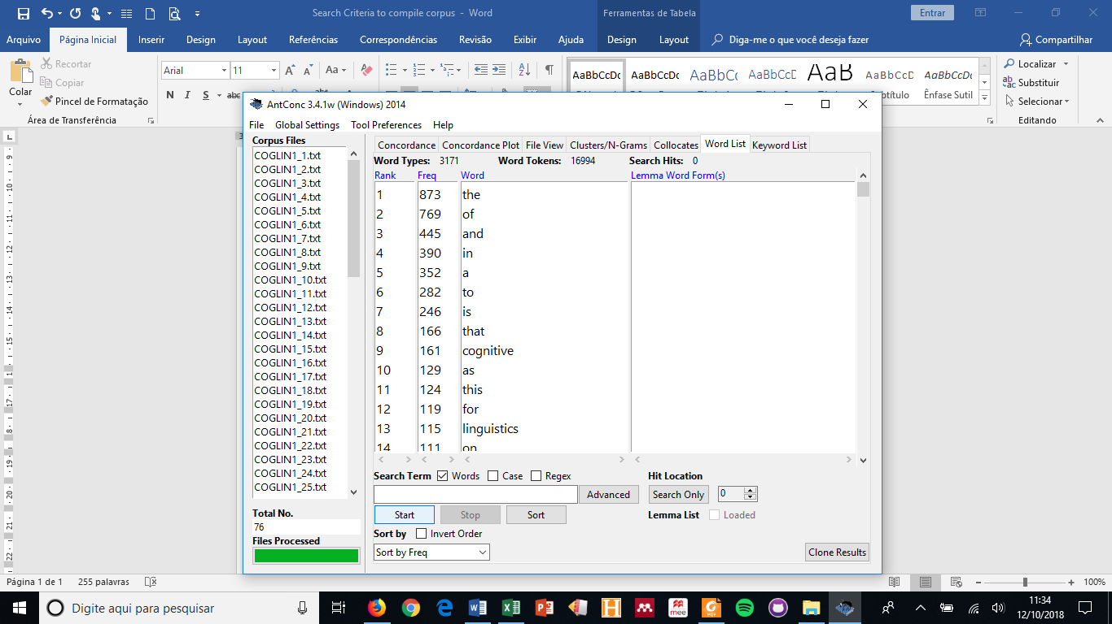

Types – 3,171 / Tokens – 16,994

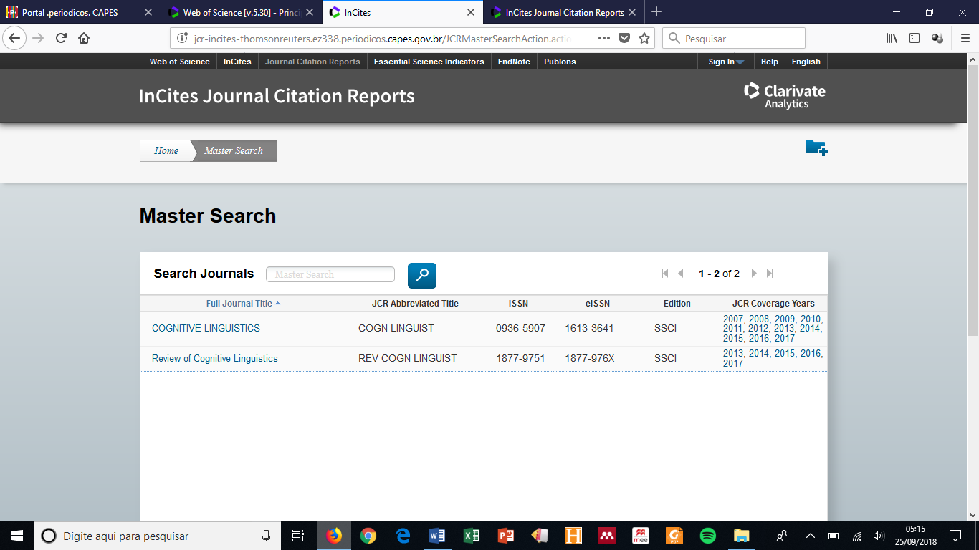

1. COGNITIVE LINGUISTICS (41)
2. REVIEW OF COGNITIVE LINGUISTICS (35)

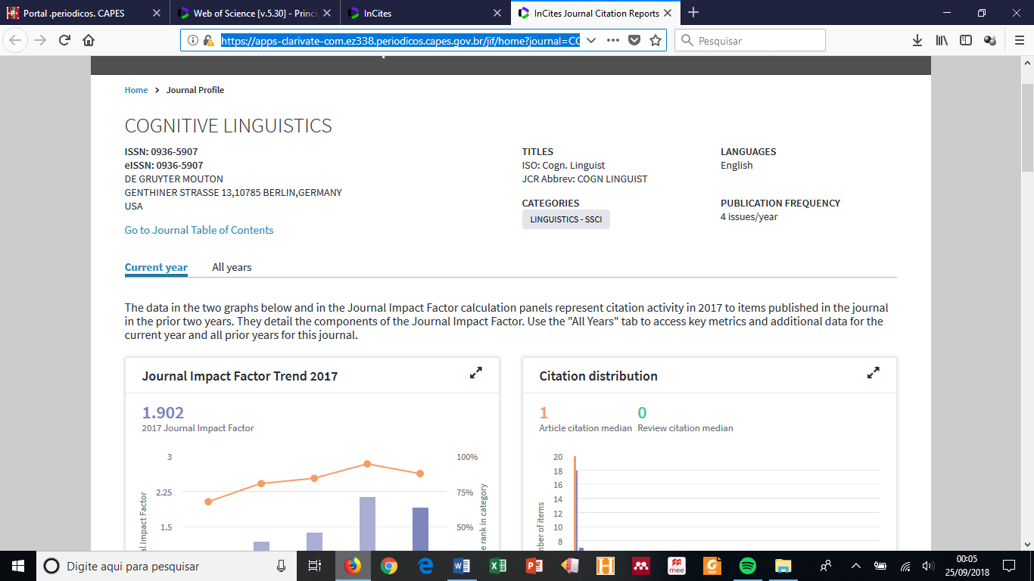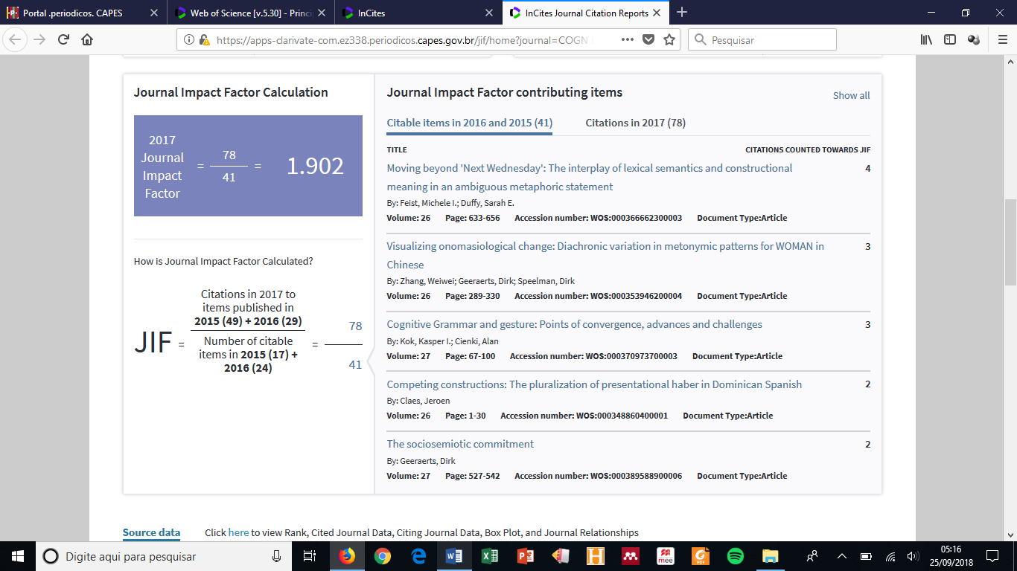

1. COGNITIVE LINGUISTICS (41)

Showing 41 citable items in 2016 and 2015

TITLE

CITATIONS COUNTED TOWARDS JIF

[Moving beyond 'Next Wednesday': The interplay of lexical semantics and constructional meaning in an ambiguous metaphoric statement](http://gateway-webofknowledge.ez338.periodicos.capes.gov.br/gateway/Gateway.cgi?GWVersion=2&SrcAuth=TSMetrics&SrcApp=TSM_TEST&DestApp=WOS_CPL&DestLinkType=FullRecord&KeyUT=WOS%3A000366662300003)

4

By: Feist, Michele I.; Duffy, Sarah E.

Volume: 26

Page: 633-656

Accession number: WOS:000366662300003

Document Type:Article

[Visualizing onomasiological change: Diachronic variation in metonymic patterns for WOMAN in Chinese](http://gateway-webofknowledge.ez338.periodicos.capes.gov.br/gateway/Gateway.cgi?GWVersion=2&SrcAuth=TSMetrics&SrcApp=TSM_TEST&DestApp=WOS_CPL&DestLinkType=FullRecord&KeyUT=WOS%3A000353946200004)

3

By: Zhang, Weiwei; Geeraerts, Dirk; Speelman, Dirk

Volume: 26

Page: 289-330

Accession number: WOS:000353946200004

Document Type:Article

[Cognitive Grammar and gesture: Points of convergence, advances and challenges](http://gateway-webofknowledge.ez338.periodicos.capes.gov.br/gateway/Gateway.cgi?GWVersion=2&SrcAuth=TSMetrics&SrcApp=TSM_TEST&DestApp=WOS_CPL&DestLinkType=FullRecord&KeyUT=WOS%3A000370973700003)

3

By: Kok, Kasper I.; Cienki, Alan

Volume: 27

Page: 67-100

Accession number: WOS:000370973700003

Document Type:Article

[Competing constructions: The pluralization of presentational haber in Dominican Spanish](http://gateway-webofknowledge.ez338.periodicos.capes.gov.br/gateway/Gateway.cgi?GWVersion=2&SrcAuth=TSMetrics&SrcApp=TSM_TEST&DestApp=WOS_CPL&DestLinkType=FullRecord&KeyUT=WOS%3A000348860400001)

2

By: Claes, Jeroen

Volume: 26

Page: 1-30

Accession number: WOS:000348860400001

Document Type:Article

[The sociosemiotic commitment](http://gateway-webofknowledge.ez338.periodicos.capes.gov.br/gateway/Gateway.cgi?GWVersion=2&SrcAuth=TSMetrics&SrcApp=TSM_TEST&DestApp=WOS_CPL&DestLinkType=FullRecord&KeyUT=WOS%3A000389588900006)

2

By: Geeraerts, Dirk

Volume: 27

Page: 527-542

Accession number: WOS:000389588900006

Document Type:Article

[Metaphor in culture: LIFE IS A SHOW in Chinese](http://gateway-webofknowledge.ez338.periodicos.capes.gov.br/gateway/Gateway.cgi?GWVersion=2&SrcAuth=TSMetrics&SrcApp=TSM_TEST&DestApp=WOS_CPL&DestLinkType=FullRecord&KeyUT=WOS%3A000375429000001)

2

By: Yu, Ning; Jia, Dingding

Volume: 27

Page: 147-180

Accession number: WOS:000375429000001

Document Type:Article

[The emergence of disjunction: A history of constructionalization in Chinese](http://gateway-webofknowledge.ez338.periodicos.capes.gov.br/gateway/Gateway.cgi?GWVersion=2&SrcAuth=TSMetrics&SrcApp=TSM_TEST&DestApp=WOS_CPL&DestLinkType=FullRecord&KeyUT=WOS%3A000370973700004)

2

By: Jing-Schmidt, Zhuo; Peng, Xinjia

Volume: 27

Page: 101-136

Accession number: WOS:000370973700004

Document Type:Article

[Cognitive vs. generative construction grammar: The case of coercion and argument structure](http://gateway-webofknowledge.ez338.periodicos.capes.gov.br/gateway/Gateway.cgi?GWVersion=2&SrcAuth=TSMetrics&SrcApp=TSM_TEST&DestApp=WOS_CPL&DestLinkType=FullRecord&KeyUT=WOS%3A000366662300002)

2

By: van Trijp, Remi

Volume: 26

Page: 613-632

Accession number: WOS:000366662300002

Document Type:Article

[Judgment evidence for statistical preemption: It is relatively better to vanish than to disappear a rabbit, but a lifeguard can equally well backstroke or swim children to shore](http://gateway-webofknowledge.ez338.periodicos.capes.gov.br/gateway/Gateway.cgi?GWVersion=2&SrcAuth=TSMetrics&SrcApp=TSM_TEST&DestApp=WOS_CPL&DestLinkType=FullRecord&KeyUT=WOS%3A000358609000003)

2

By: Robenalt, Clarice; Goldberg, Adele E.

Volume: 26

Page: 467-503

Accession number: WOS:000358609000003

Document Type:Article

[Culture or language: what drives effects of grammatical gender?](http://gateway-webofknowledge.ez338.periodicos.capes.gov.br/gateway/Gateway.cgi?GWVersion=2&SrcAuth=TSMetrics&SrcApp=TSM_TEST&DestApp=WOS_CPL&DestLinkType=FullRecord&KeyUT=WOS%3A000353946200005)

2

By: Beller, Sieghard; Brattebo, Karen Fadnes; Lavik, Kristina Osland; Reigstad, Rakel Dronen; Bender, Andrea

Volume: 26

Page: 331-359

Accession number: WOS:000353946200005

Document Type:Article

[Vision verbs dominate in conversation across cultures, but the ranking of non-visual verbs varies](http://gateway-webofknowledge.ez338.periodicos.capes.gov.br/gateway/Gateway.cgi?GWVersion=2&SrcAuth=TSMetrics&SrcApp=TSM_TEST&DestApp=WOS_CPL&DestLinkType=FullRecord&KeyUT=WOS%3A000348860400002)

1

By: Roque, Lila San; Kendrick, Kobin H.; Norcliffe, Elisabeth; Brown, Penelope; Defina, Rebecca; et al.

Volume: 26

Page: 31-60

Accession number: WOS:000348860400002

Document Type:Article

[Why Cognitive Linguistics must embrace the social and pragmatic dimensions of language and how it could do so more seriously](http://gateway-webofknowledge.ez338.periodicos.capes.gov.br/gateway/Gateway.cgi?GWVersion=2&SrcAuth=TSMetrics&SrcApp=TSM_TEST&DestApp=WOS_CPL&DestLinkType=FullRecord&KeyUT=WOS%3A000389588900007)

1

By: Schmid, Hans-Joerg

Volume: 27

Page: 543-557

Accession number: WOS:000389588900007

Document Type:Article

[Towards cognitively plausible data science in language research](http://gateway-webofknowledge.ez338.periodicos.capes.gov.br/gateway/Gateway.cgi?GWVersion=2&SrcAuth=TSMetrics&SrcApp=TSM_TEST&DestApp=WOS_CPL&DestLinkType=FullRecord&KeyUT=WOS%3A000389588900005)

1

By: Milin, Petar; Divjak, Dagmar; Dimitrijevic, Strahinja; Baayen, R. Harald

Volume: 27

Page: 507-526

Accession number: WOS:000389588900005

Document Type:Article

[What corpus-based Cognitive Linguistics can and cannot expect from neurolinguistics](http://gateway-webofknowledge.ez338.periodicos.capes.gov.br/gateway/Gateway.cgi?GWVersion=2&SrcAuth=TSMetrics&SrcApp=TSM_TEST&DestApp=WOS_CPL&DestLinkType=FullRecord&KeyUT=WOS%3A000389588900004)

1

By: Blumenthal-Drame, Alice

Volume: 27

Page: 493-505

Accession number: WOS:000389588900004

Document Type:Article

[Cognitive Linguistics' seven deadly sins](http://gateway-webofknowledge.ez338.periodicos.capes.gov.br/gateway/Gateway.cgi?GWVersion=2&SrcAuth=TSMetrics&SrcApp=TSM_TEST&DestApp=WOS_CPL&DestLinkType=FullRecord&KeyUT=WOS%3A000389588900003)

1

By: Dabrowska, Ewa

Volume: 27

Page: 479-491

Accession number: WOS:000389588900003

Document Type:Article

[Working toward a synthesis](http://gateway-webofknowledge.ez338.periodicos.capes.gov.br/gateway/Gateway.cgi?GWVersion=2&SrcAuth=TSMetrics&SrcApp=TSM_TEST&DestApp=WOS_CPL&DestLinkType=FullRecord&KeyUT=WOS%3A000389588900002)

1

By: Langacker, Ronald W.

Volume: 27

Page: 465-477

Accession number: WOS:000389588900002

Document Type:Article

[Cognitive Linguistics: Looking back, looking forward](http://gateway-webofknowledge.ez338.periodicos.capes.gov.br/gateway/Gateway.cgi?GWVersion=2&SrcAuth=TSMetrics&SrcApp=TSM_TEST&DestApp=WOS_CPL&DestLinkType=FullRecord&KeyUT=WOS%3A000389588900001)

1

By: Divjak, Dagmar; Levshina, Natalia; Klavan, Jane

Volume: 27

Page: 447-463

Accession number: WOS:000389588900001

Document Type:Article

[Baseline and elaboration](http://gateway-webofknowledge.ez338.periodicos.capes.gov.br/gateway/Gateway.cgi?GWVersion=2&SrcAuth=TSMetrics&SrcApp=TSM_TEST&DestApp=WOS_CPL&DestLinkType=FullRecord&KeyUT=WOS%3A000381013800004)

1

By: Langacker, Ronald W.

Volume: 27

Page: 405-439

Accession number: WOS:000381013800004

Document Type:Article

[Linguistic, gestural, and cinematographic viewpoint: An analysis of ASL and English narrative](http://gateway-webofknowledge.ez338.periodicos.capes.gov.br/gateway/Gateway.cgi?GWVersion=2&SrcAuth=TSMetrics&SrcApp=TSM_TEST&DestApp=WOS_CPL&DestLinkType=FullRecord&KeyUT=WOS%3A000381013800002)

1

By: Parrill, Fey; Stec, Kashmiri; Quinto-Pozos, David; Rimehaug, Sebastian

Volume: 27

Page: 345-369

Accession number: WOS:000381013800002

Document Type:Article

[When do language comprehenders mentally simulate locations?](http://gateway-webofknowledge.ez338.periodicos.capes.gov.br/gateway/Gateway.cgi?GWVersion=2&SrcAuth=TSMetrics&SrcApp=TSM_TEST&DestApp=WOS_CPL&DestLinkType=FullRecord&KeyUT=WOS%3A000375429000002)

1

By: Liu, Nian; Bergen, Benjamin

Volume: 27

Page: 181-203

Accession number: WOS:000375429000002

Document Type:Article

[Embodying metaphors: Signed language interpreters at work](http://gateway-webofknowledge.ez338.periodicos.capes.gov.br/gateway/Gateway.cgi?GWVersion=2&SrcAuth=TSMetrics&SrcApp=TSM_TEST&DestApp=WOS_CPL&DestLinkType=FullRecord&KeyUT=WOS%3A000370973700002)

1

By: Nilsson, Anna-Lena

Volume: 27

Page: 35-65

Accession number: WOS:000370973700002

Document Type:Article

[Machine Meets Man: Evaluating the Psychological Reality of Corpus-based Probabilistic Models](http://gateway-webofknowledge.ez338.periodicos.capes.gov.br/gateway/Gateway.cgi?GWVersion=2&SrcAuth=TSMetrics&SrcApp=TSM_TEST&DestApp=WOS_CPL&DestLinkType=FullRecord&KeyUT=WOS%3A000370973700001)

1

By: Divjak, Dagmar; Dabrowska, Ewa; Arppe, Antti

Volume: 27

Page: 1-33

Accession number: WOS:000370973700001

Document Type:Article

[How do gerunds conceptualize events? A diachronic study](http://gateway-webofknowledge.ez338.periodicos.capes.gov.br/gateway/Gateway.cgi?GWVersion=2&SrcAuth=TSMetrics&SrcApp=TSM_TEST&DestApp=WOS_CPL&DestLinkType=FullRecord&KeyUT=WOS%3A000366662300001)

1

By: Fonteyn, Lauren; Heyvaert, Liesbet; Maekelberghe, Charlotte

Volume: 26

Page: 583-612

Accession number: WOS:000366662300001

Document Type:Article

[Co-forming real space blends in tactile signed language dialogues](http://gateway-webofknowledge.ez338.periodicos.capes.gov.br/gateway/Gateway.cgi?GWVersion=2&SrcAuth=TSMetrics&SrcApp=TSM_TEST&DestApp=WOS_CPL&DestLinkType=FullRecord&KeyUT=WOS%3A000353946200003)

1

By: Mesch, Johanna; Raanes, Eli; Ferrara, Lindsay

Volume: 26

Page: 261-287

Accession number: WOS:000353946200003

Document Type:Article

[Making meaning: Communication between sign language users without a shared language](http://gateway-webofknowledge.ez338.periodicos.capes.gov.br/gateway/Gateway.cgi?GWVersion=2&SrcAuth=TSMetrics&SrcApp=TSM_TEST&DestApp=WOS_CPL&DestLinkType=FullRecord&KeyUT=WOS%3A000353946200002)

1

By: Zeshan, Ulrike

Volume: 26

Page: 211-260

Accession number: WOS:000353946200002

Document Type:Article

[From hand-carved to computer-based: Noun-participle compounding and the upward strengthening hypothesis](http://gateway-webofknowledge.ez338.periodicos.capes.gov.br/gateway/Gateway.cgi?GWVersion=2&SrcAuth=TSMetrics&SrcApp=TSM_TEST&DestApp=WOS_CPL&DestLinkType=FullRecord&KeyUT=WOS%3A000348860400005)

1

By: Hilpert, Martin

Volume: 26

Page: 113-147

Accession number: WOS:000348860400005

Document Type:Article

[Is conceptual blending the key to the mystery of human evolution and cognition?](http://gateway-webofknowledge.ez338.periodicos.capes.gov.br/gateway/Gateway.cgi?GWVersion=2&SrcAuth=TSMetrics&SrcApp=TSM_TEST&DestApp=WOS_CPL&DestLinkType=FullRecord&KeyUT=WOS%3A000348860400004)

1

By: Glebkin, Vladimir

Volume: 26

Page: 95-111

Accession number: WOS:000348860400004

Document Type:Article

[Cognitive grammar, speech acts, and interpersonal dynamics: A study of two directive constructions in Polish](http://gateway-webofknowledge.ez338.periodicos.capes.gov.br/gateway/Gateway.cgi?GWVersion=2&SrcAuth=TSMetrics&SrcApp=TSM_TEST&DestApp=WOS_CPL&DestLinkType=FullRecord&KeyUT=WOS%3A000348860400003)

0

By: Kochanska, Agata

Volume: 26

Page: 61-94

Accession number: WOS:000348860400003

Document Type:Article

[A multiple-grammar model of speakers' linguistic knowledge](http://gateway-webofknowledge.ez338.periodicos.capes.gov.br/gateway/Gateway.cgi?GWVersion=2&SrcAuth=TSMetrics&SrcApp=TSM_TEST&DestApp=WOS_CPL&DestLinkType=FullRecord&KeyUT=WOS%3A000353946200001)

0

By: Iwasaki, Shoichi

Volume: 26

Page: 161-210

Accession number: WOS:000353946200001

Document Type:Article

[A constructional analysis of English un-participle constructions](http://gateway-webofknowledge.ez338.periodicos.capes.gov.br/gateway/Gateway.cgi?GWVersion=2&SrcAuth=TSMetrics&SrcApp=TSM_TEST&DestApp=WOS_CPL&DestLinkType=FullRecord&KeyUT=WOS%3A000358609000002)

0

By: Schoenefeld, Doris

Volume: 26

Page: 423-466

Accession number: WOS:000358609000002

Document Type:Article

[The polysemy of the Spanish verb sentir: A behavioral profile analysis](http://gateway-webofknowledge.ez338.periodicos.capes.gov.br/gateway/Gateway.cgi?GWVersion=2&SrcAuth=TSMetrics&SrcApp=TSM_TEST&DestApp=WOS_CPL&DestLinkType=FullRecord&KeyUT=WOS%3A000358609000001)

0

By: Jansegers, Marlies; Vanderschueren, Clara; Enghels, Renata

Volume: 26

Page: 381-421

Accession number: WOS:000358609000001

Document Type:Article

[The expression of non-actual motion in Swedish, French and Thai](http://gateway-webofknowledge.ez338.periodicos.capes.gov.br/gateway/Gateway.cgi?GWVersion=2&SrcAuth=TSMetrics&SrcApp=TSM_TEST&DestApp=WOS_CPL&DestLinkType=FullRecord&KeyUT=WOS%3A000366662300004)

0

By: Blomberg, Johan

Volume: 26

Page: 657-696

Accession number: WOS:000366662300004

Document Type:Article

[With the future coming up behind them: Evidence that Time approaches from behind in Vietnamese](http://gateway-webofknowledge.ez338.periodicos.capes.gov.br/gateway/Gateway.cgi?GWVersion=2&SrcAuth=TSMetrics&SrcApp=TSM_TEST&DestApp=WOS_CPL&DestLinkType=FullRecord&KeyUT=WOS%3A000375429000003)

0

By: Sullivan, Karen; Linh Thuy Bui

Volume: 27

Page: 205-233

Accession number: WOS:000375429000003

Document Type:Article

[When variables align: A Bayesian multinomial mixed-effects model of English permissive constructions](http://gateway-webofknowledge.ez338.periodicos.capes.gov.br/gateway/Gateway.cgi?GWVersion=2&SrcAuth=TSMetrics&SrcApp=TSM_TEST&DestApp=WOS_CPL&DestLinkType=FullRecord&KeyUT=WOS%3A000375429000004)

0

By: Levshina, Natalia

Volume: 27

Page: 235-268

Accession number: WOS:000375429000004

Document Type:Article

[The role of DO-auxiliary in subject-auxiliary inversion: Developing Langacker's notion of existential negotiation](http://gateway-webofknowledge.ez338.periodicos.capes.gov.br/gateway/Gateway.cgi?GWVersion=2&SrcAuth=TSMetrics&SrcApp=TSM_TEST&DestApp=WOS_CPL&DestLinkType=FullRecord&KeyUT=WOS%3A000375429000005)

0

By: Duffley, Patrick

Volume: 27

Page: 269-287

Accession number: WOS:000375429000005

Document Type:Article

[Stability of familiarity judgments: Individual variation and the invariant bigger picture](http://gateway-webofknowledge.ez338.periodicos.capes.gov.br/gateway/Gateway.cgi?GWVersion=2&SrcAuth=TSMetrics&SrcApp=TSM_TEST&DestApp=WOS_CPL&DestLinkType=FullRecord&KeyUT=WOS%3A000381013800001)

0

By: Verhagen, Veronique; Mos, Maria

Volume: 27

Page: 307-344

Accession number: WOS:000381013800001

Document Type:Article

[Constructing signs: Place as a symbolic structure in signed languages](http://gateway-webofknowledge.ez338.periodicos.capes.gov.br/gateway/Gateway.cgi?GWVersion=2&SrcAuth=TSMetrics&SrcApp=TSM_TEST&DestApp=WOS_CPL&DestLinkType=FullRecord&KeyUT=WOS%3A000381013800003)

0

By: Wilcox, Sherman; Occhino, Corrine

Volume: 27

Page: 371-404

Accession number: WOS:000381013800003

Document Type:Article

[Turning back to experience in Cognitive Linguistics via phenomenology](http://gateway-webofknowledge.ez338.periodicos.capes.gov.br/gateway/Gateway.cgi?GWVersion=2&SrcAuth=TSMetrics&SrcApp=TSM_TEST&DestApp=WOS_CPL&DestLinkType=FullRecord&KeyUT=WOS%3A000389588900008)

0

By: Zlatev, Jordan

Volume: 27

Page: 559-572

Accession number: WOS:000389588900008

Document Type:Article

[Does historical linguistics need the Cognitive Commitment? Prosodic change in East Slavic](http://gateway-webofknowledge.ez338.periodicos.capes.gov.br/gateway/Gateway.cgi?GWVersion=2&SrcAuth=TSMetrics&SrcApp=TSM_TEST&DestApp=WOS_CPL&DestLinkType=FullRecord&KeyUT=WOS%3A000389588900009)

0

By: Nesset, Tore

Volume: 27

Page: 573-585

Accession number: WOS:000389588900009

Document Type:Article

[Typology and the future of Cognitive Linguistics](http://gateway-webofknowledge.ez338.periodicos.capes.gov.br/gateway/Gateway.cgi?GWVersion=2&SrcAuth=TSMetrics&SrcApp=TSM_TEST&DestApp=WOS_CPL&DestLinkType=FullRecord&KeyUT=WOS%3A000389588900010)

0

By: Croft, William

Volume: 27

Page: 587-602

Accession number: WOS:000389588900010

Document Type:Article

[Cognitive Linguistics, gesture studies, and multimodal communication](http://gateway-webofknowledge.ez338.periodicos.capes.gov.br/gateway/Gateway.cgi?GWVersion=2&SrcAuth=TSMetrics&SrcApp=TSM_TEST&DestApp=WOS_CPL&DestLinkType=FullRecord&KeyUT=WOS%3A000389588900011)

0

By: Cienki, Alan

Volume: 27

Page: 603-618

Accession number: WOS:000389588900011

Document Type:Article

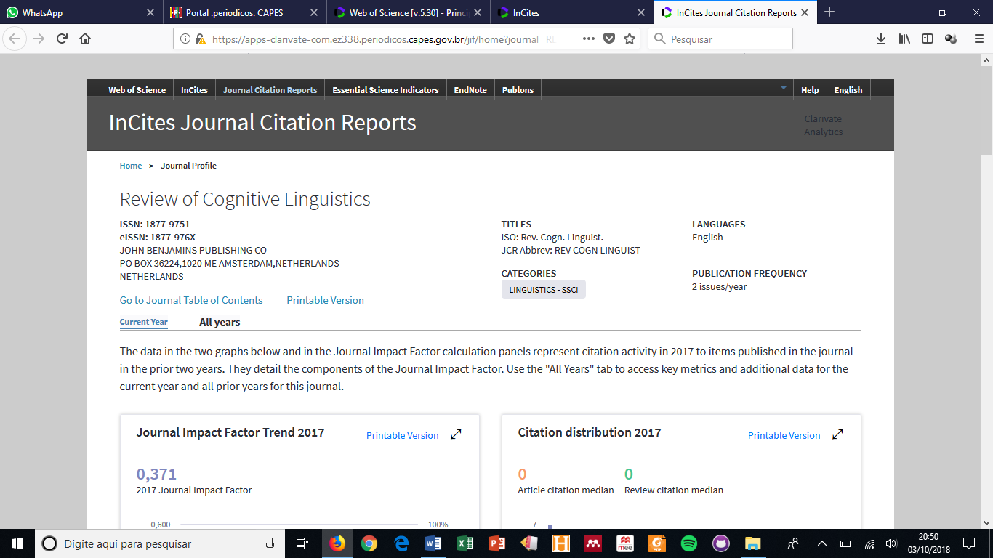

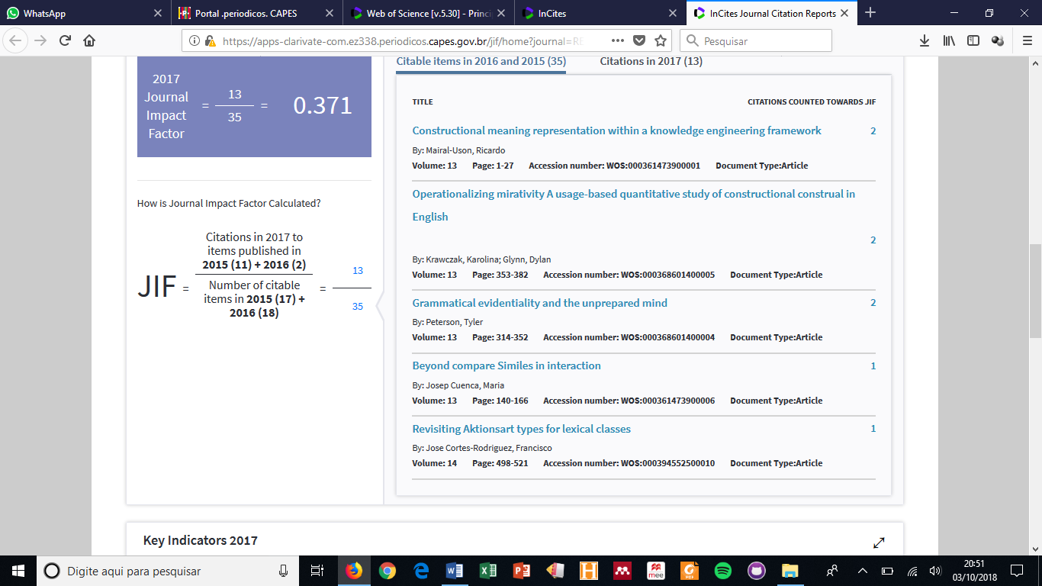

1. REVIEW OF COGNITIVE LINGUISTICS (35)

Showing 35 citable items in 2016 and 2015

TITLE

CITATIONS COUNTED TOWARDS JIF

[Constructional meaning representation within a knowledge engineering framework](http://gateway-webofknowledge.ez338.periodicos.capes.gov.br/gateway/Gateway.cgi?GWVersion=2&SrcAuth=TSMetrics&SrcApp=TSM_TEST&DestApp=WOS_CPL&DestLinkType=FullRecord&KeyUT=WOS%3A000361473900001) 2

By: Mairal-Uson, Ricardo

Volume: 13

Page: 1-27

Accession number: WOS:000361473900001

Document Type:Article

[Operationalizing mirativity A usage-based quantitative study of constructional construal in English](http://gateway-webofknowledge.ez338.periodicos.capes.gov.br/gateway/Gateway.cgi?GWVersion=2&SrcAuth=TSMetrics&SrcApp=TSM_TEST&DestApp=WOS_CPL&DestLinkType=FullRecord&KeyUT=WOS%3A000368601400005) 2

By: Krawczak, Karolina; Glynn, Dylan

Volume: 13

Page: 353-382

Accession number: WOS:000368601400005

Document Type:Article

[Grammatical evidentiality and the unprepared mind](http://gateway-webofknowledge.ez338.periodicos.capes.gov.br/gateway/Gateway.cgi?GWVersion=2&SrcAuth=TSMetrics&SrcApp=TSM_TEST&DestApp=WOS_CPL&DestLinkType=FullRecord&KeyUT=WOS%3A000368601400004) 2

By: Peterson, Tyler

Volume: 13

Page: 314-352

Accession number: WOS:000368601400004

Document Type:Article

[Beyond compare Similes in interaction](http://gateway-webofknowledge.ez338.periodicos.capes.gov.br/gateway/Gateway.cgi?GWVersion=2&SrcAuth=TSMetrics&SrcApp=TSM_TEST&DestApp=WOS_CPL&DestLinkType=FullRecord&KeyUT=WOS%3A000361473900006) 1

By: Josep Cuenca, Maria

Volume: 13

Page: 140-166

Accession number: WOS:000361473900006

Document Type:Article

[Revisiting Aktionsart types for lexical classes](http://gateway-webofknowledge.ez338.periodicos.capes.gov.br/gateway/Gateway.cgi?GWVersion=2&SrcAuth=TSMetrics&SrcApp=TSM_TEST&DestApp=WOS_CPL&DestLinkType=FullRecord&KeyUT=WOS%3A000394552500010) 1

By: Jose Cortes-Rodriguez, Francisco

Volume: 14

Page: 498-521

Accession number: WOS:000394552500010

Document Type:Article

[On-line processing of verb-argument constructions Visual recognition threshold and naming latency](http://gateway-webofknowledge.ez338.periodicos.capes.gov.br/gateway/Gateway.cgi?GWVersion=2&SrcAuth=TSMetrics&SrcApp=TSM_TEST&DestApp=WOS_CPL&DestLinkType=FullRecord&KeyUT=WOS%3A000379156700005) 1

By: Ellis, Nick C.

Volume: 14

Page: 105-135

Accession number: WOS:000379156700005

Document Type:Article

[The complex, language-specific semantics of surprise](http://gateway-webofknowledge.ez338.periodicos.capes.gov.br/gateway/Gateway.cgi?GWVersion=2&SrcAuth=TSMetrics&SrcApp=TSM_TEST&DestApp=WOS_CPL&DestLinkType=FullRecord&KeyUT=WOS%3A000368601400003) 1

By: Goddard, Cliff

Volume: 13

Page: 291-313

Accession number: WOS:000368601400003

Document Type:Article

[Surprise as a conceptual category](http://gateway-webofknowledge.ez338.periodicos.capes.gov.br/gateway/Gateway.cgi?GWVersion=2&SrcAuth=TSMetrics&SrcApp=TSM_TEST&DestApp=WOS_CPL&DestLinkType=FullRecord&KeyUT=WOS%3A000368601400002) 1

By: Koevecses, Zoltan

Volume: 13

Page: 270-290

Accession number: WOS:000368601400002

Document Type:Article

[Surprise and human-agent interactions](http://gateway-webofknowledge.ez338.periodicos.capes.gov.br/gateway/Gateway.cgi?GWVersion=2&SrcAuth=TSMetrics&SrcApp=TSM_TEST&DestApp=WOS_CPL&DestLinkType=FullRecord&KeyUT=WOS%3A000368601400009) 1

By: Clavel, Chloe

Volume: 13

Page: 461-477

Accession number: WOS:000368601400009

Document Type:Article

[Surprise in the GRID](http://gateway-webofknowledge.ez338.periodicos.capes.gov.br/gateway/Gateway.cgi?GWVersion=2&SrcAuth=TSMetrics&SrcApp=TSM_TEST&DestApp=WOS_CPL&DestLinkType=FullRecord&KeyUT=WOS%3A000368601400008) 1

By: Soriano, Cristina; Fontaine, Johnny R. J.; Scherer, Klaus R.

Volume: 13

Page: 436-460

Accession number: WOS:000368601400008

Document Type:Article

['I'm dying on you' Constructions of intensification in Hebrew expression of love/desire/adoration](http://gateway-webofknowledge.ez338.periodicos.capes.gov.br/gateway/Gateway.cgi?GWVersion=2&SrcAuth=TSMetrics&SrcApp=TSM_TEST&DestApp=WOS_CPL&DestLinkType=FullRecord&KeyUT=WOS%3A000361473900002) 0

By: Vardi, Ruti

Volume: 13

Page: 28-58

Accession number: WOS:000361473900002

Document Type:Article

[Accent-induced coder bias](http://gateway-webofknowledge.ez338.periodicos.capes.gov.br/gateway/Gateway.cgi?GWVersion=2&SrcAuth=TSMetrics&SrcApp=TSM_TEST&DestApp=WOS_CPL&DestLinkType=FullRecord&KeyUT=WOS%3A000361473900003) 0

By: Sloos, Marjoleine

Volume: 13

Page: 59-80

Accession number: WOS:000361473900003

Document Type:Article

[Medical term formation in English and Japanese A study of the suffixes -gram, -graph and -graphy](http://gateway-webofknowledge.ez338.periodicos.capes.gov.br/gateway/Gateway.cgi?GWVersion=2&SrcAuth=TSMetrics&SrcApp=TSM_TEST&DestApp=WOS_CPL&DestLinkType=FullRecord&KeyUT=WOS%3A000361473900004) 0

By: Herrero-Zorita, Carlos; Molina, Clara; Moreno-Sandoval, Antonio

Volume: 13

Page: 81-105

Accession number: WOS:000361473900004

Document Type:Article

[Conceptual metaphor in the complex dynamics of illocutionary meaning](http://gateway-webofknowledge.ez338.periodicos.capes.gov.br/gateway/Gateway.cgi?GWVersion=2&SrcAuth=TSMetrics&SrcApp=TSM_TEST&DestApp=WOS_CPL&DestLinkType=FullRecord&KeyUT=WOS%3A000361473900005) 0

By: Baicchi, Annalisa

Volume: 13

Page: 106-139

Accession number: WOS:000361473900005

Document Type:Article

[Visualization and conceptual metaphor as tools for the teaching of abstract motion in German](http://gateway-webofknowledge.ez338.periodicos.capes.gov.br/gateway/Gateway.cgi?GWVersion=2&SrcAuth=TSMetrics&SrcApp=TSM_TEST&DestApp=WOS_CPL&DestLinkType=FullRecord&KeyUT=WOS%3A000361473900007) 0

By: De Knop, Sabine

Volume: 13

Page: 167-190

Accession number: WOS:000361473900007

Document Type:Article

[Intonation unit boundaries and the storage of bigrams Evidence from bidirectional and directional association measures](http://gateway-webofknowledge.ez338.periodicos.capes.gov.br/gateway/Gateway.cgi?GWVersion=2&SrcAuth=TSMetrics&SrcApp=TSM_TEST&DestApp=WOS_CPL&DestLinkType=FullRecord&KeyUT=WOS%3A000361473900008) 0

By: Wahl, Alexander

Volume: 13

Page: 191-219

Accession number: WOS:000361473900008

Document Type:Article

[Cross-linguistic variation in metonymies for PERSON A Chinese-English contrastive study](http://gateway-webofknowledge.ez338.periodicos.capes.gov.br/gateway/Gateway.cgi?GWVersion=2&SrcAuth=TSMetrics&SrcApp=TSM_TEST&DestApp=WOS_CPL&DestLinkType=FullRecord&KeyUT=WOS%3A000361473900009) 0

By: Zhang, Weiwei; Geeraerts, Dirk; Speelman, Dirk

Volume: 13

Page: 220-255

Accession number: WOS:000361473900009

Document Type:Article

[The computer-mediated expression of surprise A corpus analysis of chats by English and Italian native speakers and Italian learners of English](http://gateway-webofknowledge.ez338.periodicos.capes.gov.br/gateway/Gateway.cgi?GWVersion=2&SrcAuth=TSMetrics&SrcApp=TSM_TEST&DestApp=WOS_CPL&DestLinkType=FullRecord&KeyUT=WOS%3A000368601400006) 0

By: Ascone, Laura

Volume: 13

Page: 383-414

Accession number: WOS:000368601400006

Document Type:Article

[Surprise routines in scientific writing A study of French social science articles](http://gateway-webofknowledge.ez338.periodicos.capes.gov.br/gateway/Gateway.cgi?GWVersion=2&SrcAuth=TSMetrics&SrcApp=TSM_TEST&DestApp=WOS_CPL&DestLinkType=FullRecord&KeyUT=WOS%3A000368601400007) 0

By: Tutin, Agnes

Volume: 13

Page: 415-435

Accession number: WOS:000368601400007

Document Type:Article

[Overt and covert uses of metaphor in the academic mentoring in English of Spanish undergraduate students at five European universities](http://gateway-webofknowledge.ez338.periodicos.capes.gov.br/gateway/Gateway.cgi?GWVersion=2&SrcAuth=TSMetrics&SrcApp=TSM_TEST&DestApp=WOS_CPL&DestLinkType=FullRecord&KeyUT=WOS%3A000379156700002) 0

By: MacArthur, Fiona

Volume: 14

Page: 23-50

Accession number: WOS:000379156700002

Document Type:Article

[The interpretation of metonymy by Japanese learners of English](http://gateway-webofknowledge.ez338.periodicos.capes.gov.br/gateway/Gateway.cgi?GWVersion=2&SrcAuth=TSMetrics&SrcApp=TSM_TEST&DestApp=WOS_CPL&DestLinkType=FullRecord&KeyUT=WOS%3A000379156700003) 0

By: Littlemore, Jeannette; Arizono, Satomi; May, Alice

Volume: 14

Page: 51-72

Accession number: WOS:000379156700003

Document Type:Article

[Methodological triangulation in the study of emotion The case of 'anger' in three language groups](http://gateway-webofknowledge.ez338.periodicos.capes.gov.br/gateway/Gateway.cgi?GWVersion=2&SrcAuth=TSMetrics&SrcApp=TSM_TEST&DestApp=WOS_CPL&DestLinkType=FullRecord&KeyUT=WOS%3A000379156700004) 0

By: Ogarkova, Anna; Soriano, Cristina; Gladkova, Anna

Volume: 14

Page: 73-101

Accession number: WOS:000379156700004

Document Type:Article

[The role of force dynamics and intentionality in the reconstruction of L2 verb meanings A Danish-Spanish bidirectional study](http://gateway-webofknowledge.ez338.periodicos.capes.gov.br/gateway/Gateway.cgi?GWVersion=2&SrcAuth=TSMetrics&SrcApp=TSM_TEST&DestApp=WOS_CPL&DestLinkType=FullRecord&KeyUT=WOS%3A000379156700006) 0

By: Ibarretxe-Antunano, Iraide; Cadierno, Teresa; Hijazo-Gascon, Alberto

Volume: 14

Page: 136-160

Accession number: WOS:000379156700006

Document Type:Article

[Cross-linguistic influence in the interpretation of boundary-crossing events in L2 acquisition](http://gateway-webofknowledge.ez338.periodicos.capes.gov.br/gateway/Gateway.cgi?GWVersion=2&SrcAuth=TSMetrics&SrcApp=TSM_TEST&DestApp=WOS_CPL&DestLinkType=FullRecord&KeyUT=WOS%3A000379156700007) 0

By: Alonso, Rosa

Volume: 14

Page: 161-182

Accession number: WOS:000379156700007

Document Type:Article

[Thinking for translating and intra-typological variation in satellite-framed languages](http://gateway-webofknowledge.ez338.periodicos.capes.gov.br/gateway/Gateway.cgi?GWVersion=2&SrcAuth=TSMetrics&SrcApp=TSM_TEST&DestApp=WOS_CPL&DestLinkType=FullRecord&KeyUT=WOS%3A000379156700008) 0

By: Lewandowski, Wojciech; Mateu, Jaume

Volume: 14

Page: 185-208

Accession number: WOS:000379156700008

Document Type:Article

[Showing versus telling Representing speech events in English and Spanish](http://gateway-webofknowledge.ez338.periodicos.capes.gov.br/gateway/Gateway.cgi?GWVersion=2&SrcAuth=TSMetrics&SrcApp=TSM_TEST&DestApp=WOS_CPL&DestLinkType=FullRecord&KeyUT=WOS%3A000379156700009) 0

By: Caballero, Rosario

Volume: 14

Page: 209-233

Accession number: WOS:000379156700009

Document Type:Article

[Applying Cognitive Linguistics Identifying some current research foci (figurative language in use, constructions and typology)](http://gateway-webofknowledge.ez338.periodicos.capes.gov.br/gateway/Gateway.cgi?GWVersion=2&SrcAuth=TSMetrics&SrcApp=TSM_TEST&DestApp=WOS_CPL&DestLinkType=FullRecord&KeyUT=WOS%3A000379156700001) 0

By: Ma Piquer-Piriz, Ana; Alejo, Rafael

Volume: 14

Page: 1-20

Accession number: WOS:000379156700001

Document Type:Article

[The Finnish abstract motion construction menna V-mA-An [go V-INF-ILL] 'do something unwished' Usage, development and motivation](http://gateway-webofknowledge.ez338.periodicos.capes.gov.br/gateway/Gateway.cgi?GWVersion=2&SrcAuth=TSMetrics&SrcApp=TSM_TEST&DestApp=WOS_CPL&DestLinkType=FullRecord&KeyUT=WOS%3A000394552500002) 0

By: Sivonen, Jari

Volume: 14

Page: 247-274

Accession number: WOS:000394552500002

Document Type:Article

[The cross-cultural analysis of the metaphorical conceptualization of HAPPINESS in English and Vietnamese Idioms can tell](http://gateway-webofknowledge.ez338.periodicos.capes.gov.br/gateway/Gateway.cgi?GWVersion=2&SrcAuth=TSMetrics&SrcApp=TSM_TEST&DestApp=WOS_CPL&DestLinkType=FullRecord&KeyUT=WOS%3A000394552500003) 0

By: Van Trao Nguyen

Volume: 14

Page: 275-302

Accession number: WOS:000394552500003

Document Type:Article

[Walking and running in English and German The conceptual semantics of verbs of human locomotion](http://gateway-webofknowledge.ez338.periodicos.capes.gov.br/gateway/Gateway.cgi?GWVersion=2&SrcAuth=TSMetrics&SrcApp=TSM_TEST&DestApp=WOS_CPL&DestLinkType=FullRecord&KeyUT=WOS%3A000394552500004) 0

By: Goddard, Cliff; Wierzbicka, Anna; Wong, Jock

Volume: 14

Page: 303-336

Accession number: WOS:000394552500004

Document Type:Article

[The polysemy of the Croatian verbal prefix od-](http://gateway-webofknowledge.ez338.periodicos.capes.gov.br/gateway/Gateway.cgi?GWVersion=2&SrcAuth=TSMetrics&SrcApp=TSM_TEST&DestApp=WOS_CPL&DestLinkType=FullRecord&KeyUT=WOS%3A000394552500005) 0

By: Belaj, Branimir; Buljan, Gabrijela

Volume: 14

Page: 337-384

Accession number: WOS:000394552500005

Document Type:Article

[English and Mandarin speakers' mental representations of time Some new evidence about the language-thought relationship](http://gateway-webofknowledge.ez338.periodicos.capes.gov.br/gateway/Gateway.cgi?GWVersion=2&SrcAuth=TSMetrics&SrcApp=TSM_TEST&DestApp=WOS_CPL&DestLinkType=FullRecord&KeyUT=WOS%3A000394552500006) 0

By: Yang, Wenxing; Sun, Ying

Volume: 14

Page: 385-415

Accession number: WOS:000394552500006

Document Type:Article

[The externality of anger as conceptualized in Kiswahili](http://gateway-webofknowledge.ez338.periodicos.capes.gov.br/gateway/Gateway.cgi?GWVersion=2&SrcAuth=TSMetrics&SrcApp=TSM_TEST&DestApp=WOS_CPL&DestLinkType=FullRecord&KeyUT=WOS%3A000394552500007) 0

By: Kahumburu, Monica

Volume: 14

Page: 416-441

Accession number: WOS:000394552500007

Document Type:Article

[Communicating flexibly with metaphor A complex of strengthening, elaboration, replacement, compounding and unrealism](http://gateway-webofknowledge.ez338.periodicos.capes.gov.br/gateway/Gateway.cgi?GWVersion=2&SrcAuth=TSMetrics&SrcApp=TSM_TEST&DestApp=WOS_CPL&DestLinkType=FullRecord&KeyUT=WOS%3A000394552500008) 0

By: Barnden, John

Volume: 14

Page: 442-473

Accession number: WOS:000394552500008

Document Type:Article

[Argument structure and implicational constructions at the crossroads](http://gateway-webofknowledge.ez338.periodicos.capes.gov.br/gateway/Gateway.cgi?GWVersion=2&SrcAuth=TSMetrics&SrcApp=TSM_TEST&DestApp=WOS_CPL&DestLinkType=FullRecord&KeyUT=WOS%3A000394552500009) 0

By: Sandra Pena-Cervel, Ma

Volume: 14

Page: 474-497

Accession number: WOS:000394552500009

Document Type:Article